Setting Compute Resource Priority Using Tags

8/5/2021

Stephen Mak

VMware

**Use case:**

In vRA7, the user can give a priority to each provisioning resource. See picture in appendix A. Although this capability is not supported by vRA8 yet, the user can accomplish the same via tagging. This document lists the steps and includes an implementation package. The user imports the package to vRO and configures vRA8 per instruction below.

**Instruction:**

Step 1: Defining a “priority tag” for each provisioning resource. Tag format is *priority:#*, where # is a digit between 1 to 9. 1 is the highest priority. 9 is the lowest priority. In the picture, three compute resources are tagged.

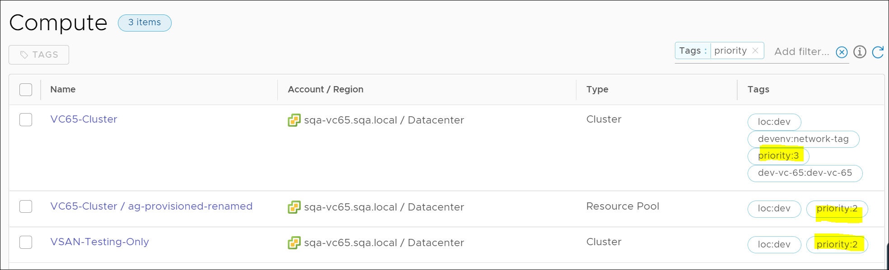

Step 2: Adding compute resources to cloud zone

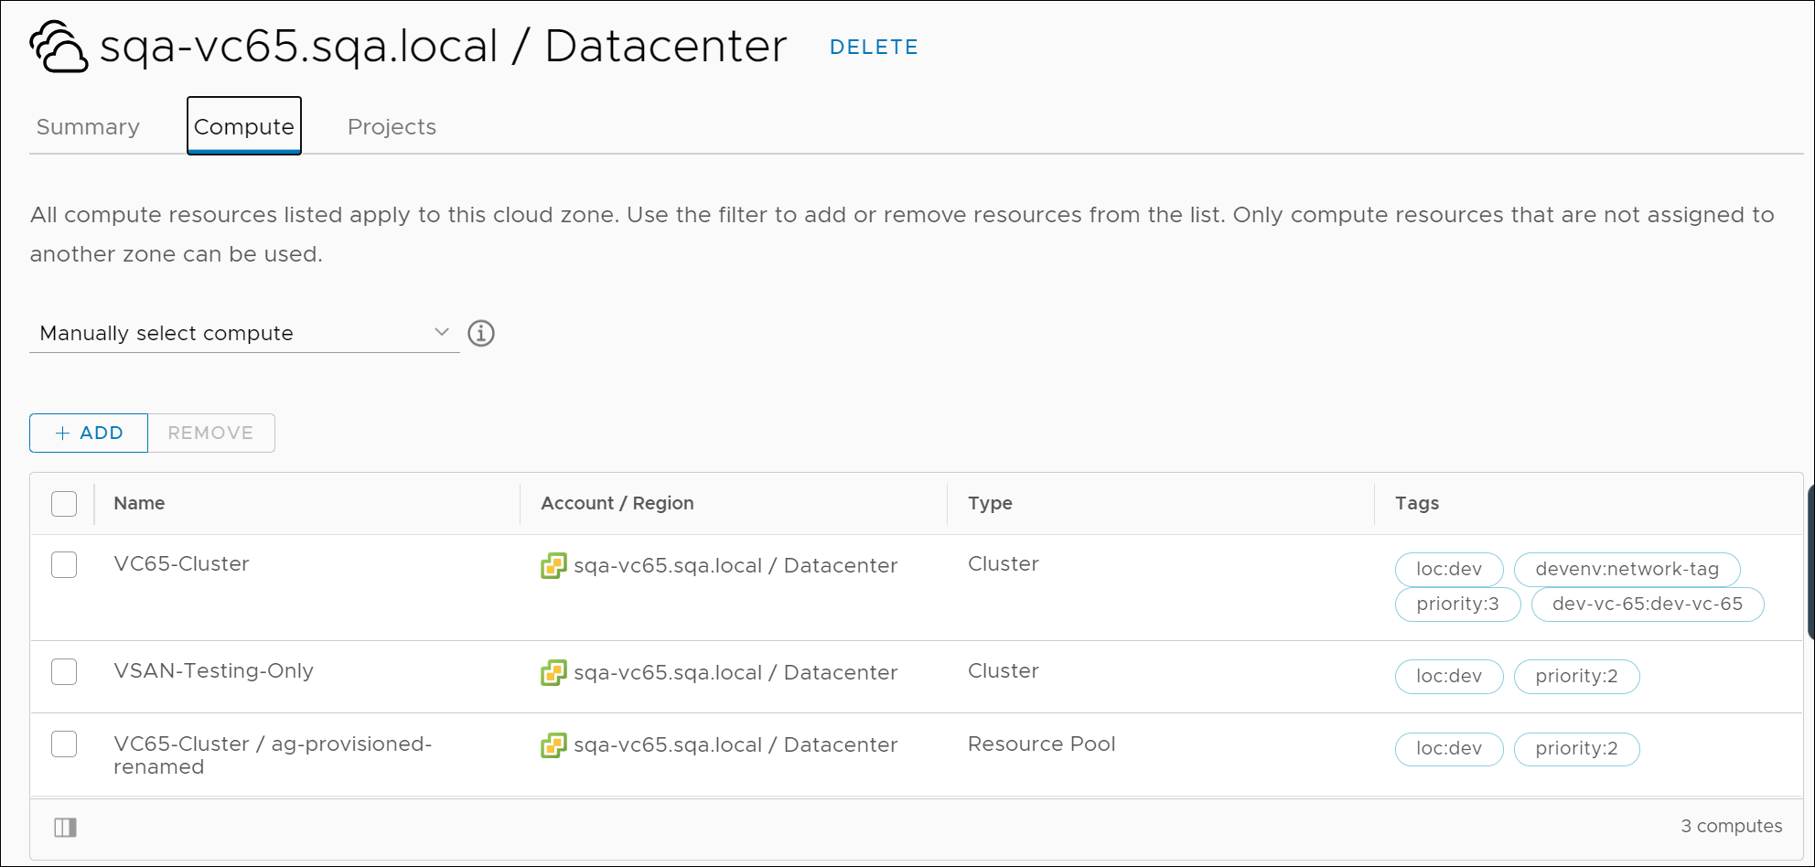

Step 3: Creating a compute allocation subscription

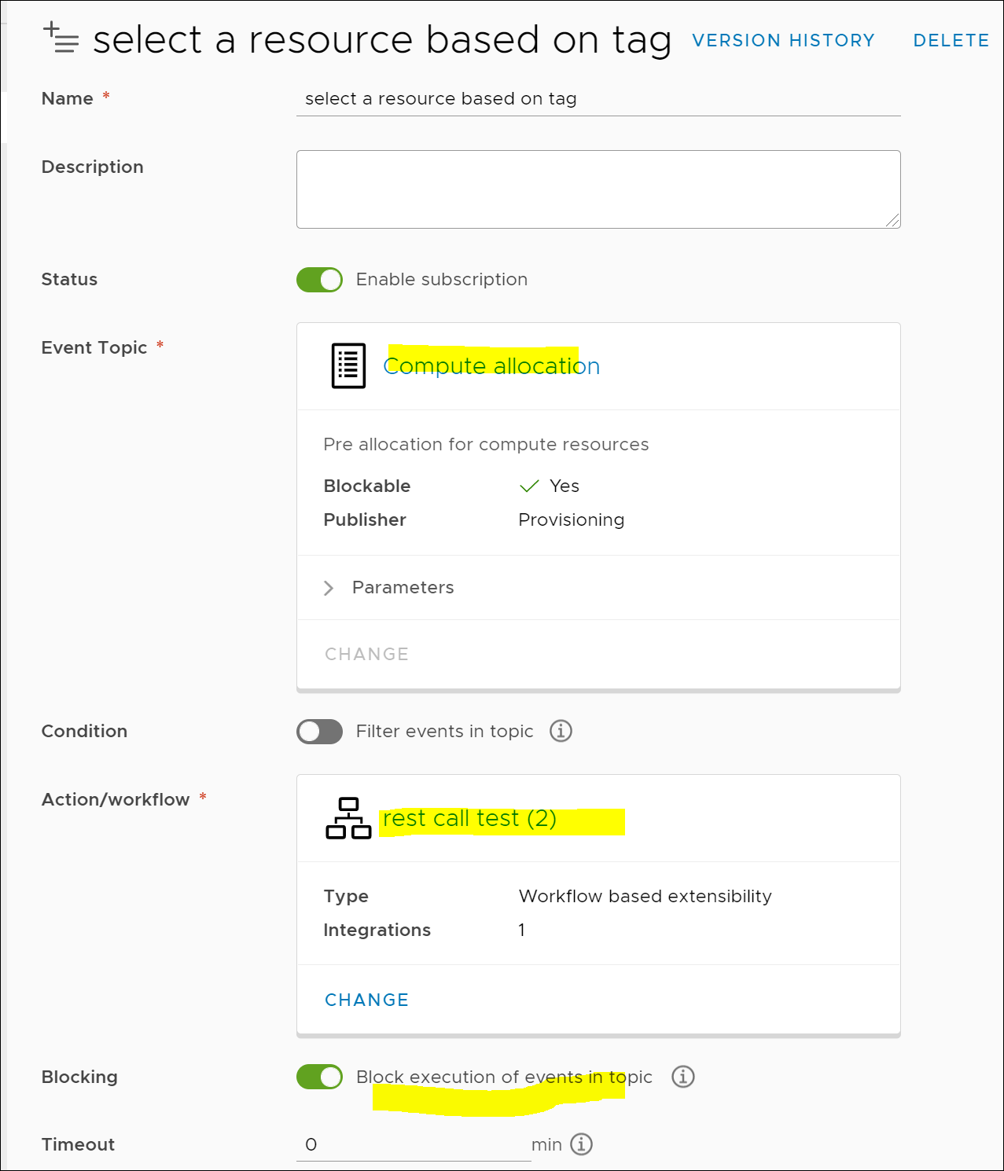

Step 4: selecting the workflow from the package. The workflow examines the matching compute resources and selects one based on priority tag. In the picture, the hostSelectionIds parameter contains three matching compute resources.

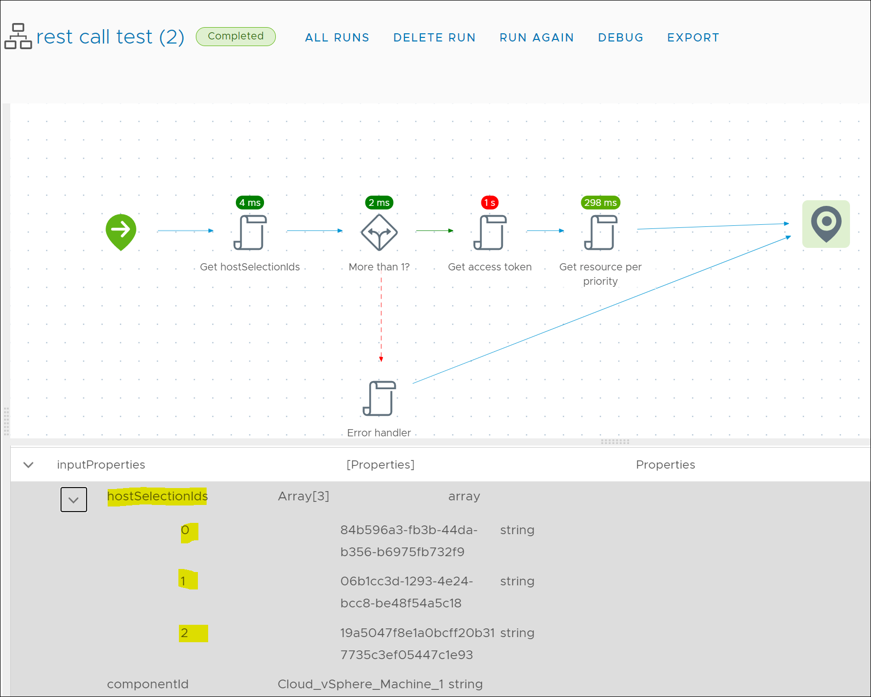

Step 5: Because two of the matching compute resources had the same priority tag, workflow selects the last element of the two.

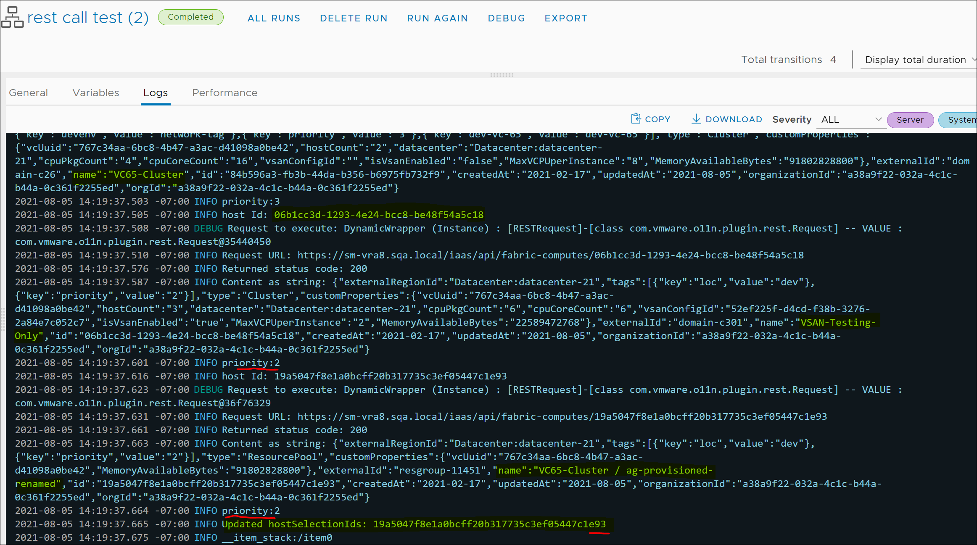

Step 6: If no compute resources had a priority tag, workflow selects the first element from the matching list.

Step 7: Creating a request to try out

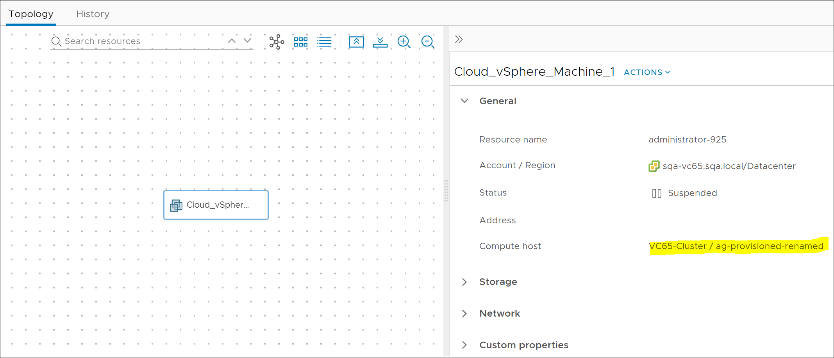

# Appendix A vRA7 Reservation with Priority

Below is an example

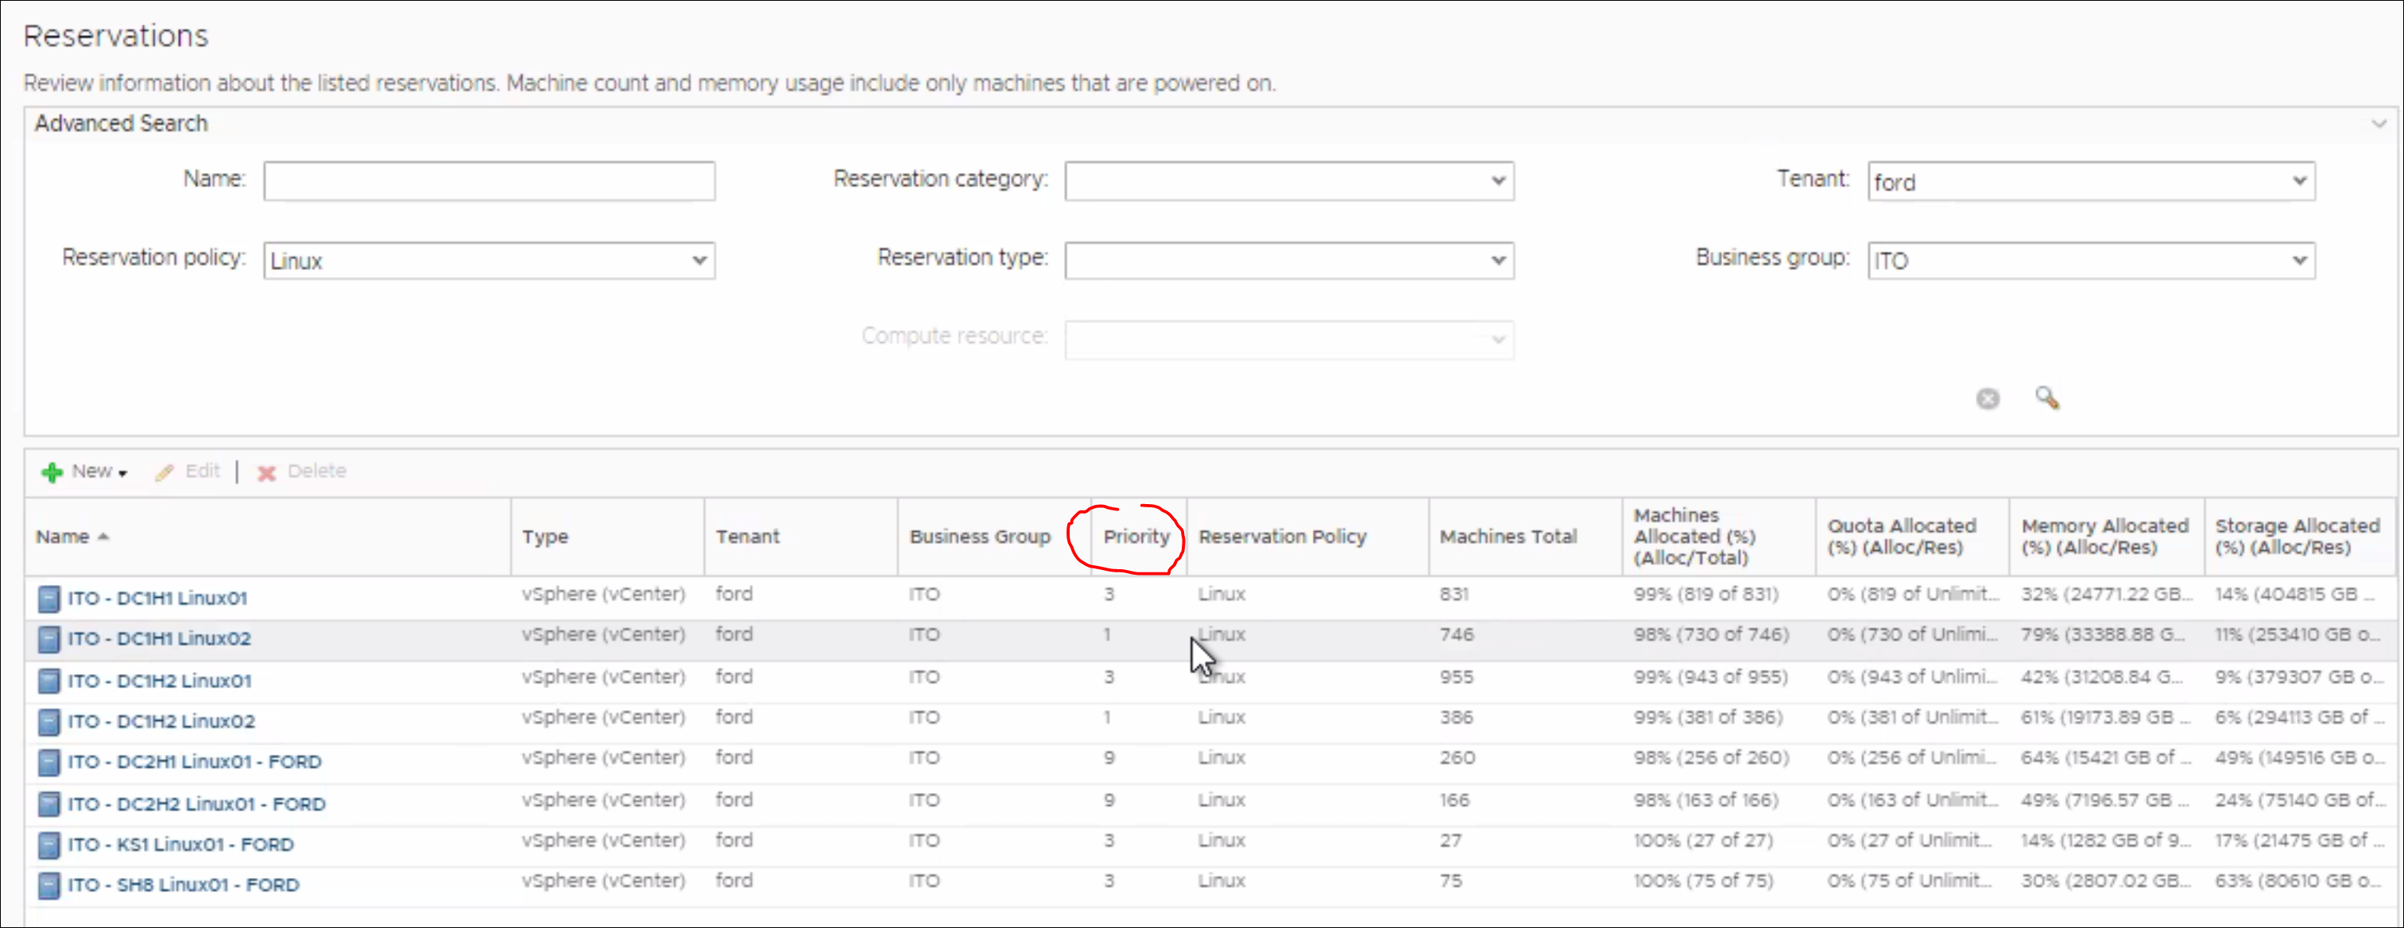

# Appendix B vRO8 Workflows

